Course Recommender System in a Liberal Arts Context

Raphaël Morsomme
University College Maastricht
Zwingelput 4
6211 KH Maastricht
(+32496486716)
raphael.morsomme@maastrichtuniversity.nl
Sofia Vazquez Alferez
University College Maastricht
Zwingelput 4
6211 KH Maastricht
(+31625246406)
sofia.vazquezalferez@maastrichtuniversity.nl

ABSTRACT
This paper describes a direct application of topic modelling and sequential rule mining to provide transparent course recommendations to students of the Liberal Arts and Sciences Bachelor from University College Maastricht, based on their academic interests and performance in previous courses. The system is developed to complement academic advising and help students make well informed decisions. We find that course recommendations based on a topic modeling of course descriptions are useful and that sequence mining provides a rough method to control for prerequisites.
Keywords
Course recommendation, warning system, open curriculum, topic model, pre-requisite discovery.

INTRODUCTION
The Bachelor in Liberal Arts offered at the University College Maastricht, the Netherlands, is an honors program characterized by an open curriculum. The program allows students to design their curriculum in a fairly free fashion: more than 75% of the educational credits are free, the college offers more than 150 courses covering a wide range of topics from artificial intelligence, to conflict resolution and to pop songs, and students can take up to one year’s worth of courses at other departments of Maastricht University. This freedom allows students to tailor their curriculum to their own interests, but the large number of courses available makes the selection of courses overwhelming. Firstly, the number of courses offered at the 12 departments of the university is too large for students to have an overview of which ones match their academic interests. Secondly, since each student of the Liberal Arts program has a unique curriculum, it can be difficult for a student to determine if she/he has covered the necessary prerequisites for a particular course or if the course’s level is too advanced given her/his academic background. A system that identifies courses matching a student’s academic interests and warns them if they are not ready yet for a particular course would therefore be extremely beneficial for the student of the liberal arts program. It increased their information position, thereby improving self-advising, and, used as an agenda-setting tool, it also improve academic advising.
Our course recommender system consists of two pillars which achieve both goals: courses suggestions and warnings. To receive course suggestions, the student enters her/his academic interest. The system returns 10 courses that match the indicated interests and are thus potentially interesting for the student. In practice, the student selects key words that represent her/his academic interests from a predetermined list and the course recommender system uses a topic model fitted with the Latent Dirichlet Allocation algorithm (Blei, 2003) to identify the 10 courses whose content best matches the topics corresponding to the selected key words (see figure X). To receive warnings, students provide their transcript and indicate which courses they are considering for the following term. The system issues a warning for the courses that it identifies as too advanced given the current academic background of the student. In practice, the student enters her/his student ID with which the system accesses her/his past academic performance. From it, the system identifies the skills acquired by the student and, using a lasso-regularized linear regression model fitted to each individual course (Tibshirani, 1996), it estimates the grade that the student will obtain in the selected courses and issues a warning when the predicted grade is a fail (see figure X).
For such data-driven system, opaqueness can be an impediment to an effective use (Castelvecchi, 2016). If the system is opaque, students and academic advisors are more likely to see it as a black box and not take its recommendations seriously. To tackle this issue, we have made the system as transparent as possible: a course suggestion includes which of the selected key words led to it and a list of potential preparatory coursework is attached to each warning.
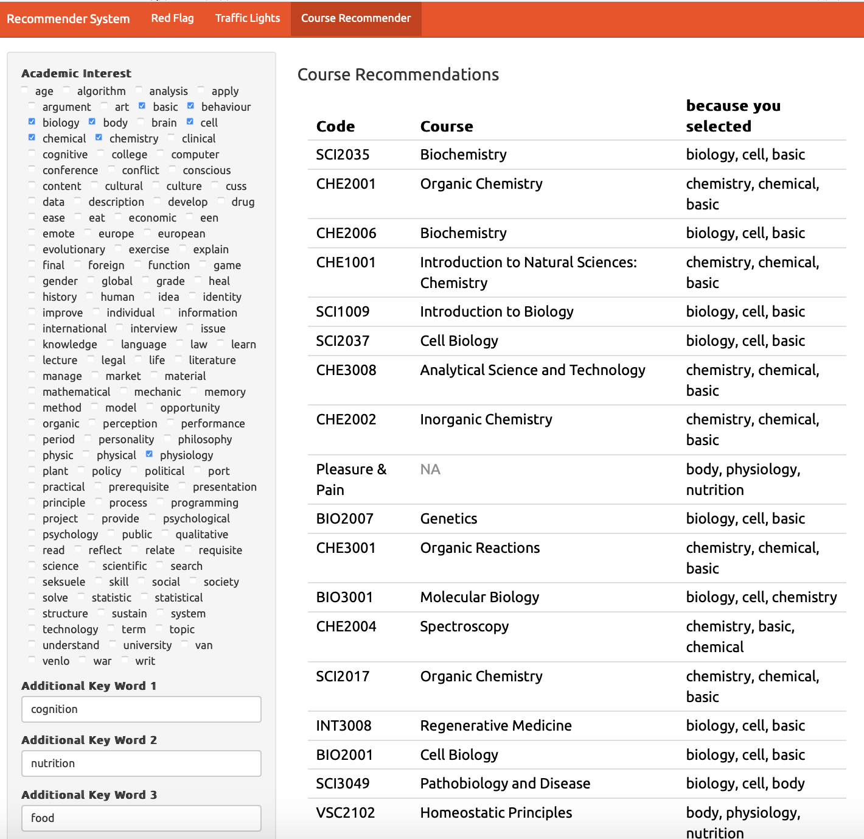
Figure X. Course suggestions in practice (TODO: UPDATE)
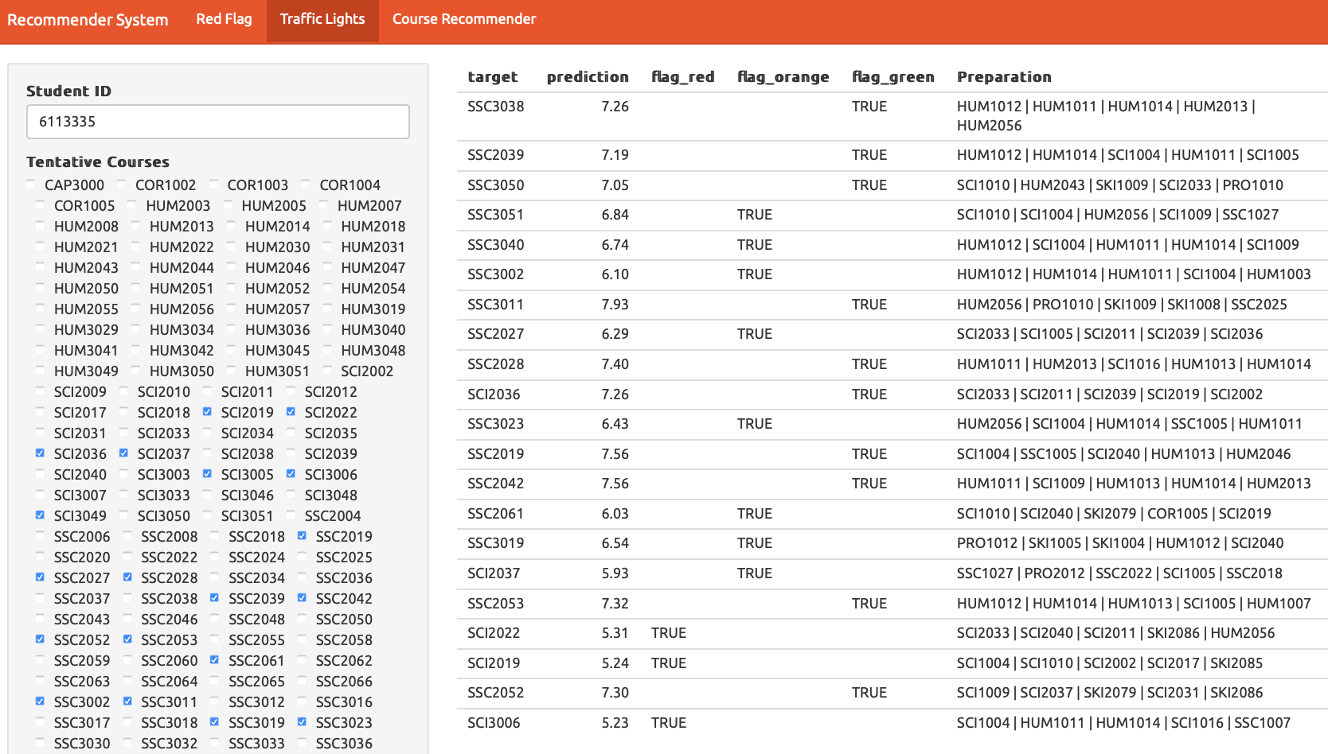
Figure X. Warning in practice (TODO: UPDATE FIGURE)

METHODOLOGY

Data
We use two types of data: student data and course data.
The student data consists of anonymized course enrollment information. We use the transcripts of the 2,526 students of the liberal arts program between 2008 and 2019 with a total of 79,245 course enrollments. We exclude course enrollments with a missing grade, indicating that the student either dropped the course or fail the attendance requirement. In the latter case, an observation corresponding to the resit is present in the data set. Figure X presents the student data. Each row contains an anonymized student ID, a course ID, a year and semester, and the obtained grade.
The course data consists of the 2018-2019 course catalogues of five departments of Maastricht University: European Studies, University College Maastricht, University College Venlo, Psychology and Science Program. These course catalogues contains a one-page description of 490 courses. Figure X presents the textual data in the tidy format with one row per document-term (Wickham, 2014). We follow common data cleaning procedure in text mining: we tokenize the individual terms, stem them with the Hunspell Stemmer and remove common stop words, numbers between 1 and 1,000, and terms that occur less than three times in the data set (Meyer, Hornik, & Feinerer, 2008).
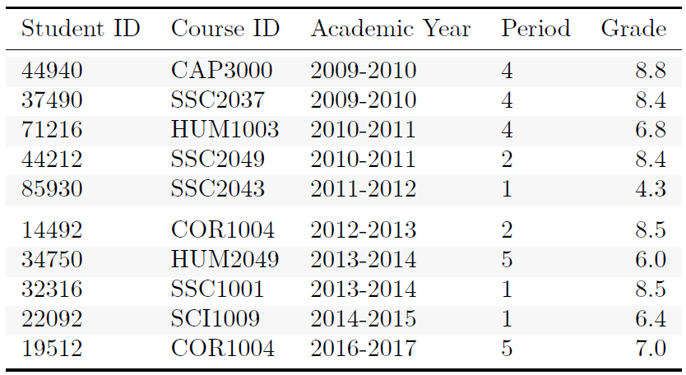
Figure X. Example of student data.

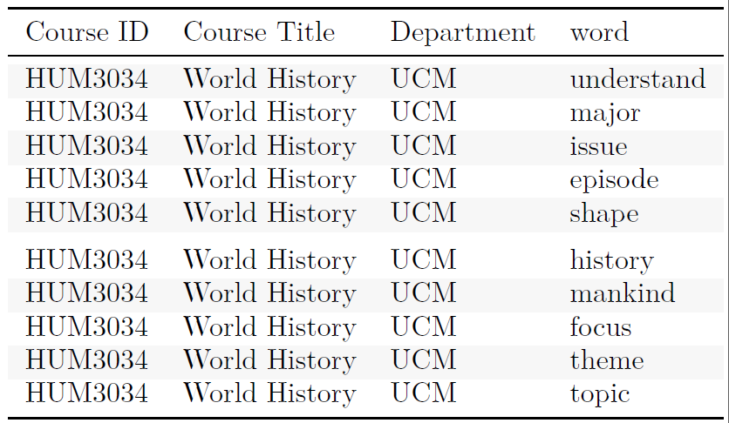
Figure 2. Example of course data.

Approach
The course recommender system is composed of two pillars: course recommendations and red flags. This division is motivated by the two challenges that students face when choosing which courses to enroll in for the following term: among the thousands of courses offered at the university, which ones match my academic interests and which ones have a level that suits my academic background. We consider course recommendations in the traditional sense of selecting the top-n courses based on some predefined ranking metric. Warnings are issued when the system identifies course that are too advanced for the student given the skills she/he has acquired in past course. All computations are conducted on R.
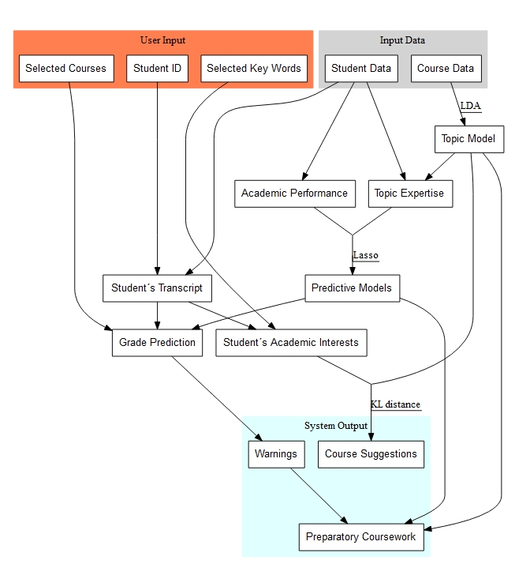
Figure X. Flowchart

Topic Model

Warnings
We fit a predictive model for grade for each of the 148 courses currently offered at the college that have had more than 20 student enrollments since 2008.
The model is a multivariate linear regression model. The predictors consist of students’ past academic performance and their level of expertise in each topic at the start of the course.
Students’ past academic performance consists of 6 variables corresponding to their general GPA and their concentration-specific GPA at the beginning of the course.
Students’ level of expertise consists of a 35 variables (one per topic of the topic model) that indicate how much knowledge of the topic a student has acquired through his curriculum. In a sense, topic expertise approximates the skills acquired by the student. These set of topic expertise corresponds to the sum of the importance of the topic in the courses taken by the student (as estimated by the topic model) weighted by her/his grades. The assumption is that a student who obtains 10/10 in a course has acquired all the topics present in it while a student who obtains 5/10 has only acquired half of the topics. Figure X presents a toy example of the contribution of individual courses towards a student’s topic expertise.
We use the lasso penalty to regularize the models and use 10-fold cross validation to find the value for the lasso parameter λ that yields the smallest mean average prediction error.

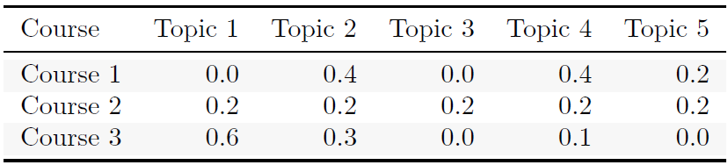
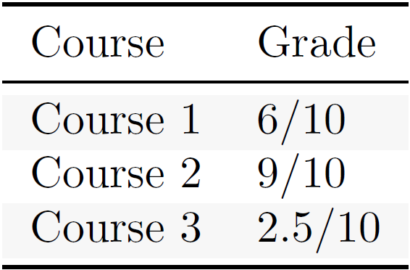
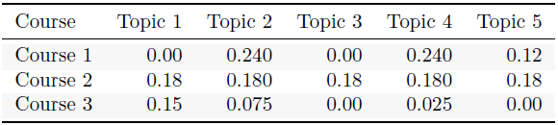
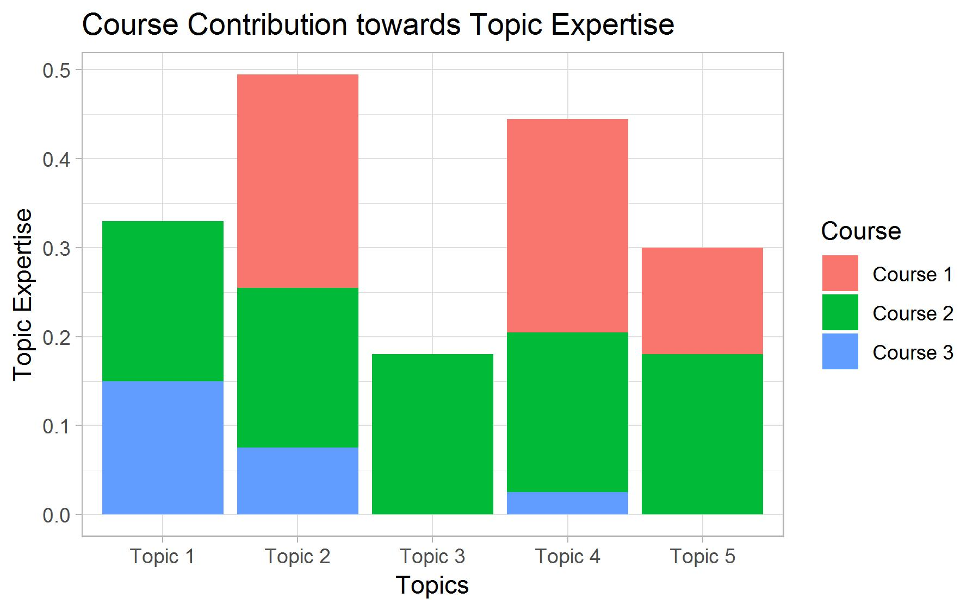

Figure X: Toy example of topic expertise with 3 courses and 5 topics. The upper table presents the distribution of topic per course (gamma coefficients from a topic model). The middle table indicates the grades obtained by a student in these courses. The bottom table and the barplot indicate the contribution of each course to the topic expertise profile of the student after taking these courses. The topic expertise variables are then used as predictor in the predictive model.

Rule-based Warnings
We investigated an alternative approach for warnings based on association rules. We used the CSPADE algorithm (REF) to identify sequences in the students transcripts of the type <fail course A> => <fail course B> and <not take course A> => <fail course B> and considered rules with a support superior to 10 students, a confidence superior to 0.4 and a lift superior to 1.1. Warnings were issued when a student indicate that they considered taking a course for which one the selected rules indicates that she/he is likely to fail it.
Although this approach is very transparent, which motivated its initial adoption, it turned out to be unsuitable to our case. First, given the small size of our sample and the fact that relatively few students fail courses at the college, only 21 rules met the criteria. Second, this approach ignores the fact that skills can be acquired in several courses.
To tackle the first issue, we considered a relaxed version of the rules that substitutes a <fail course A> with a <obtain less than 6.5 in course A>. This increased the number of rules meeting the criteria to 185. Yet, the second issue remained and led us to consider a regressive predicting model that uses topic expertise as a proxy for skills that a necessary to perform well in a course.

Preparatory Coursework
In order to be transparent and help student design their curriculum, each warning is accompanied by a list of preparatory course work.
To provide warnings we mine the student data using the CSPADE algorithm. Given a set of sequences, the CSPADE algorithm identifies all subsequences with a support superior to a given threshold. Since we are working with a relatively small number of observations (around 2,526 student, each taking around 40 courses), we restrict the search to two item sequences, i.e. rules with a single antecedent and a single consequent. Each item is a dyad composed of a course and grade (<course, grade>). We also identify sequences whose antecedent is a course that has not been taken (see Figure 3, second red flag). The obtained subsequences can be conceptualized as association rules whose left-hand side is anterior to the right-hand side. We only consider sequences whose right-hand side corresponds to a low performance i.e. a grade of 7 or lower (using a stricter threshold i.e. a failing grade of 5.4 produces rules with extremely low support) and have a count superior to 20 students, a confidence superior to 0.4 and lift superior to 1.1.
To provide red flags, we ask the student to enter the courses s(he) intends to take the following semester. We then, select all rules that have one of the prospective courses as a consequent and check whether the student’s transcript contains any of the <course, grade> dyads that appear as antecedents in the selected rules. If this is the case, we issue a red flag for the course that matches the consequent; otherwise, no warning is given. In order to make the red flags transparent, we provide a numerical summary of the subsequence on which the red flag is based.
We are currently working on an alternative approach to red flags based on the competences acquired by students throughout their curriculum. We are also working on providing a list of courses that a student faced with a red flag could follow as a preparation to the course flagged by the system.

Course Recommendation
To provide Course Recommendations, we identify the courses whose content best match the academic interests of the students. First, we identify the topics covered by a course with the help of a topic model fit on the course data with a Latent Dirichlet Allocation (LDA) algorithm. A topic model allows the probabilistic modeling of term frequency occurrences in documents by providing a probability distributions of topics per document (i.e. per course), and of words per topic. We fit topic models on the most recent course catalogue and on the course manuals. In the future, we hope to be able to fit a topic model on the academic literature of each course to obtain a more detailed representation of course content. We vary three parameters of the algorithm – number of topics, alpha and beta – and select the model with the best log-likelihood (Figure 1). At the time of this writing, we are still evaluating the optimal value of the latter two parameters; yet, the current topic model already gives very good recommendations. In the future, we may also consider two alternative metrics: perplexity and coherence.
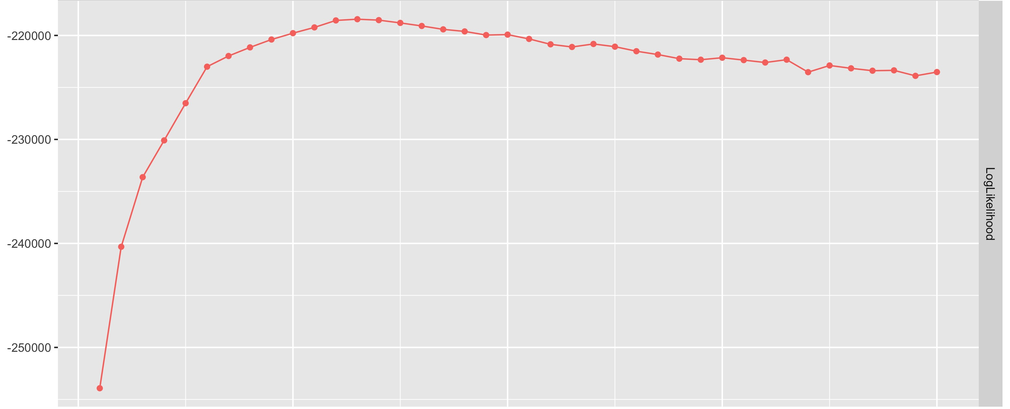
Figure X. Log Likelihood of Topic Models on Course Catalogues for different numbers of topics.
Second, we map the key words introduced by the students into the system to the topics identified by the topic model. This way, we establish a topic profile of the student which consists of a numeric vector indicating the importance of each topic for the student. At the moment, student topic profiles are established only via the key words they enter in the system, but we are working on building a more complete profile by allow students to indicate courses and academic literature whose content particularly match their interests. Finally, we rank the courses based on their match with the topic profile of the student and recommend the top n courses.
To make these recommendations transparent, we include the key words that led to a course being recommended.

RESULTS
This is work in progress, yet the results are promising. Course recommendations were particularly satisfactory. The recommended courses follow logically from the selected key words; an opinion that was corroborated by faculty members, academic advisors and current students of the liberal arts program. An example of the outcome can be seen in Figure 2.

Figure 1.Example of Course Recommendations

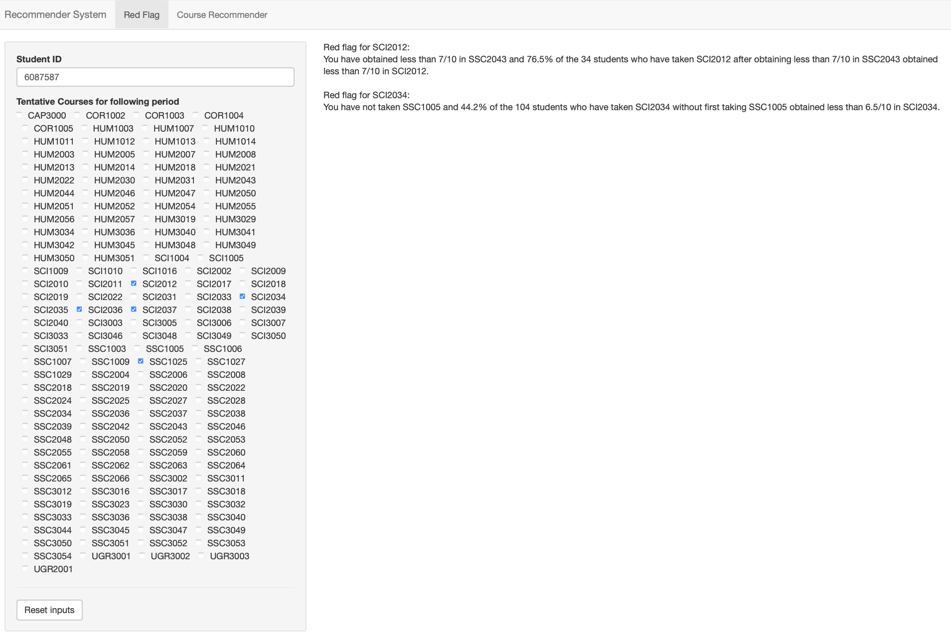
Figure 2. Example of Red Flags
Results for red flags were less satisfactory. Given the relatively small number of students, the large number of course and the flexibility of the program, sequences tends to have a low support and to be particularly sensitive to variance. Moreover, in its current form, the system does not permit to over-ride red flags; that is, even if there is ample evidence that a student is able to perform well in a course, if (s)he matches a single sequence, then a red flag is issued. Figure 3 provides an example of red flags.

FURTHER RESEARCH
course data: use manuals, then literature
In the light of these results, we would like to continue improving both pillars of the course recommender system. First, we would like to include course information from the other departments. This way, the system could recommend courses to the students which they had never considered because they ignored they existence and did not know that their content suit their academic interest. We also want to elaborate a more complete topic profile of student by taking into account courses or journal articles that the student found particularly interesting. Second, given the limited success of red flags based only on performance in past courses, we would like take into account the competences that the students acquire during their curriculum. One such approach is to consider the topics that the student has covered in past courses (obtained from a topic model).

ACKNOWLEDGMENTS
Our thanks to the University College Maastricht, the Institute of Data Science, Maastricht University, and the Department of Data Science and Knowledge Engineering, Maastricht University, in particular to Evgueni Smirnov, and Peter Vermeer for supporting this project with their expertise.

REFERENCES
- Blei, D. M., Ng, A. Y., & Jordan, M. I. (2003). Latent dirichlet allocation. Journal of machine Learning research, 3(Jan), 993-1022.
- Castelvecchi, D. (2016). Can we open the black box of AI?. Nature News, 538(7623), 20.
- Hornik, K., & Grün, B. (2011). topicmodels: An R package for fitting topic models. Journal of Statistical Software, 40(13), 1-30.
- Meyer, D., Hornik, K., & Feinerer, I. (2008). Text mining infrastructure in R. Journal of statistical software, 25(5), 1-54. URL http://www.jstatsoft.org/v25/i05/.
- R Core Team. 2017. R: A language and environment for statistical computing. R Foundation for Statistical Computing, Vienna.
- Tibshirani, R. (1996). Regression shrinkage and selection via the lasso. Journal of the Royal Statistical Society: Series B (Methodological), 58(1), 267-288.
- Wickham, H. (2014). Tidy data. Journal of Statistical Software, 59(10), 1-23. doi:10.18637/jss.v059.i10.

Courses offered at the college are divided into 5 concentrations: humanities, natural sciences, social science, skills and projects

